MULLINS PRESBYTERIAN CHURCH
“The Church Behind The Cross”

The Service of Worship March 14, 2021

“Holy Spirit, fill your church with enthusiasm and energy to work for
good in the world. Amen.”
----------------------
“Let the prelude be to you a call to silent prayer.”
----------------------
PRELUDE
CALL TO WORSHIP WELCOME AND ANNOUNCEMENTS
**SCRIPTURE READING Romans 12:1-2
INVOCATION AND LORD’S PRAYER
**GLORIA PATRI (Played only)

APOSTOLES CREED
INTERLUDE

CHILDREN’S SERMON

PRESENTATION OF TITHES AND OFFERINGS
Offertory
Prayer of Dedication and Doxology (Played only)

**SCRIPTURE READING 1 Peter 2 4-10
⁴ To whom coming, as unto a living stone, disallowed indeed of men, but chosen of God, and precious “: verse 4

SERMON
“Come to Jesus” Pastor PRAYER
SPECIAL MUSIC
**BENEDICTION Rom. 8:38-39

POSTLUDE “Amazing Grace” Played as rows are dismissed.
**Congregation please stand

ANNOUNCEMENTS

Welcoming Today – George McMillan
Deacon of the Day – Brian Hopkins
Nursery – Grace Burton and Jessica Huggins
Flowers – The beautiful flowers are placed to the glory of God and in honor of Betty and George Smith on their 65th wedding anniversary by their children, grandchildren, and great-grandchildren.

Today in our Church

- 5:30-6:30 Kingdom Kids
- Jr. & Sr. High Youth- Parents, Wyatt and Amanda will meet you and your child at the door for entry and exit.
Kingdom Kids and Youth – Please wear your masks.

This Week in our Church
Monday 5PM – Agape fellowship – A special meeting for girls ages 13-18 at the home of Nikki and Kaitlynn Hopkins – 301 Azalea Street.

Wednesday 6:15– Prayer meeting

Lily forms are in back of the sanctuary. Deadline to order lilies is March 21, 2021. The cost is $10.00 per lily.

Mark your calendars for the Kingdom Kids Easter Egg Hunt on March 28, 2021 at 5:00PM. This year the Easter Egg Hunt will be held at Homestead Venue in Zion. Each child is asked to bring an Easter basket.

Mission Mullins will be June 14-18. Please be in prayer how you can be involved.

Circle will resume on April 13, 2021 at 6:30PM.

“Always show kindness and love to others. Your words might be filling the empty places in someone’s heart.” Mandy Hale

Mullins Presbyterian Church
“The Church Behind the Cross”

This church is a fellowship of people who are trusting in Jesus Christ as Savior, Lord, and Friend. We believe the Bible to be inerrant, written Word of God and the only infallible rule of faith and practice. We believe the system of doctrine taught in the Scriptures is set forth in the Westminster Confession of Faith and the larger and shorter catechisms.
We preach without apology, the changeless gospel of God’s saving grace, the faith which was once delivered to the saints. We would love to have you join us in fellowship. To inquire, please see the pastor or one of the elders at the close of the service.
Visit our church website, www.mullinspres.com Or email us at
Mullinspresbyterian@outlook.com

1 Peter 2:4-10
⁴ To whom coming, as unto a living stone, disallowed indeed of men, but chosen of God, and precious,⁵ Ye also, as lively stones, are built up a spiritual house, an holy priesthood, to offer up spiritual sacrifices, acceptable to God by Jesus Christ.⁶ Wherefore also it is contained in the scripture, Behold, I lay in Sion a chief corner stone, elect, precious: and he that believeth on him shall not be confounded.⁷ Unto you therefore which believe he is precious: but unto them which be disobedient, the stone which the builders disallowed, the same is made the head of the corner,⁸ And a stone of stumbling, and a rock of offence, even to them which stumble at the word, being disobedient: whereunto also they were appointed.⁹ But ye are a chosen generation, a royal priesthood, an holy nation, a peculiar people; that ye should shew forth the praises of him who hath called you out of darkness into his marvellous light;¹⁰ Which in time past were not a people, but are now the people of God: which had not obtained mercy, but now have obtained mercy.
Mullins Presbyterian Church, P.C.A.
Mullins, SC
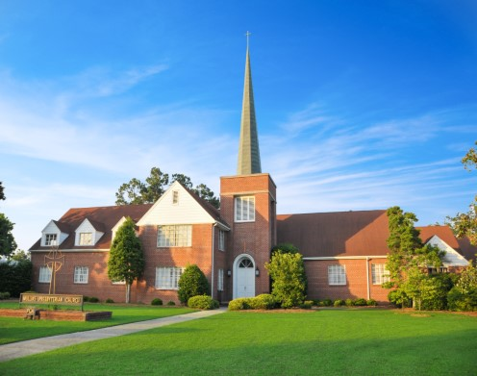

2021
“A YEAR TO FOCUS ON DISCIPLESHIP”

