MULLINS PRESBYTERIAN CHURCH
“The Church Behind the Cross”

The Service of Worship October 17, 2021

For beautiful fall days, I thank you Lord! Help me find reason to praise
you every day.
----------------------
“Let the prelude be to you a call to silent prayer.”
----------------------
PRELUDE
WELCOME AND ANNOUNCEMENTS
VERBAL CALL TO WORSHIP Philippians 2:1-11
INTERLUDE
INVOCATION AND LORD’S PRAYER

**GLORIA PATRI
HYMN “Alleluia! Sing to Jesus” 174
CHILDREN’S SERMON

PRESENTATION OF TITHES AND OFFERINGS
Offertory
**Prayer of Dedication and Doxology

SCRIPTURE READING Revelation 5 ² And I saw a mighty angel proclaiming with a loud voice, “Who is worthy to open the scroll and break its seals?” (Pew Bible-New Testament page 967)
SERMON “ Worthy is the Lamb” Drew Jackson PRAYER
SPECIAL MUSIC

**BENEDICTION
POSTLUDE “Amazing Grace”
**Congregation please stand.

ANNOUNCEMENTS

Welcoming Today – Lon Spivey
Deacon of the Day – Splinter Spivey
Nursery – Kyra, Spider, Briar, Jessley, and Sealey Spivey
Flowers- The beautiful flowers gracing the sanctuary today are placed to the glory of God and in loving memory of a wonderful mother, Jean Smith, on her birthday (October 18) by her four children who love and miss her very much.

Today in our Church
5:30-6:30 Kingdom Kids and Sr. High Youth

This Week in our Church
Monday 3:00-4:15 Meet at the church to go to go to King’s Court and share God’s love with the children at the afterschool program. See Taylor Jackson or Sandra Pipkin for more details.

Monday 5PM Agape Fellowship-A special meeting for girls 13-18 at the home of Nikki and Kaitlynn Hopkins-301 Azalea Drive

Tuesday 6:30PM Ladies Bible Study in the fellowship hall. (Respectable Sins-Chapter 4)

Wednesday 7:30-8:30 AM Men of Mullins Prayer Breakfast/ The prayer breakfast is at Seth Creech’s shop, 6040 Paul’s Path Road. See Seth for more information.

Wednesday 6:15PM Prayer meeting. The lesson will be from Chapter 4 in The Gospel of the 40 Days.

Sunday at 8:00AM Session Meeting

October 31,2021 5:30-7:00PM Fall Festival at Splinter and Kristi’s house. We will have a hot dog supper, games, and more activities.

If your child is interested in attending a communicant’s class, please call the church office or let Drew know at the close of the service.

We are delighted to welcome Drew Jackson to our pulpit this morning. Drew serves as our ministry intern and has done an excellent job assisting us with Mission Mullins, Sunday school, and many other outreach ministries. He and his wife, Taylor, also serve in our community as teachers at Pee Dee Academy.

Mullins Presbyterian Church
The Church Behind the Cross”

This church is a fellowship of people who are trusting in Jesus Christ as Savior, Lord, and Friend. We believe the Bible to be inerrant, written Word of God and the only infallible rule of faith and practice. We believe the system of doctrine taught in the Scriptures is set forth in the Westminster Confession of Faith and the larger and shorter catechisms.
We preach without apology, the changeless gospel of God’s saving grace, the faith which was once delivered to the saints. We would love to have you join us in fellowship. To inquire, please see the pastor or one of the elders at the close of the service.

Visit our church website, www.mullinspres.com Or email us at
Mullinspresbyterian@outlook.com

Missionaries Supported by our Church

Fellowship of Christian Athletes Mission Mullins

S2AD ( Tony Eubanks) Curt Moore

PCA Chaplain Ministries Ed and Vicki Germann

Glenn and Sharlene Grubb Tommy and Konni Logan

Bill Villanueva Joe and Ann Lyle

Peter and Dianne Bakelaar Pete and Ruth Mitchell

Marc and Aline Mailloux Debbie Richards

Tommy and Lucy Wright

MULLINS

PRESBYTERIAN CHURCH

P.C.A.

MULLINS, SC

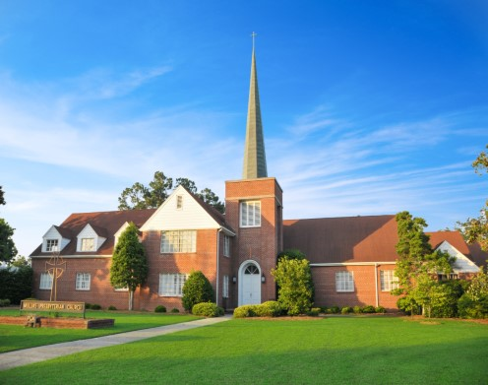

2021

“A YEAR TO FOCUS ON DISCIPLESHIP”

