MULLINS PRESBYTERIAN CHURCH
“The Church Behind the Cross”

The Service of Worship February 27, 2022

Divine Spirit, open my ears to hear your Word, my heart to receive it and
my mouth to respond in praise. Amen.
----------------------
“Let the prelude be to you a call to silent prayer.”
----------------------
PRELUDE
WELCOME AND ANNOUNCEMENTS
CALL TO WORSHIP

INTERLUDE
INVOCATION AND LORD’S PRAYER
**GLORIA PATRI
**HYMN “Rescue the Perishing” 480
CHILDREN’S SERMON
SPECIAL MUSIC

PRESENTATION OF TITHES AND OFFERINGS
OFFERTORY
**PRAYER OF DEDICATION AND DOXOLOGY
INTRODUCTION OF GUEST PREACHER

**SCRIPTURE READING 2 Kings 4:1-7
2 And Elisha said to her, “What shall I do for you? Tell me; what have you in the house?” And she said, “Your servant has nothing in the house except a jar of oils.
SERMON “God’s Arithmetic” Tom Wright

PRAYER
HYMN “God of Grace and God of Glory” 466

FAITH PROMISE INVITATION
**BENEDICTION
POSTLUDE “Amazing Grace”
**Congregation please stand.
Announcements Welcoming Today –Sandy Garner Deacon of the Day –Brian Hopkins Nursery –Sonya Foster and Tonya Martin Flowers - The beautiful flowers gracing the sanctuary today are placed to the glory of God.
Today in our Church 5:30-6:30PM Kingdom Kids and Jr. and Sr. High Youth
5:30PM Choir practice We will meet in the sanctuary to allow for social distancing. This Week in our Church Monday 5:00PM Agape Fellowship-A special meeting for girls 13-18 at the home of Nikki and Kaitlynn Hopkins-301 Azalea Drive.
Tuesday 6:30PM Circle will meet in the fellowship hall/Chapter 3 Red Sea Rules

Wednesday 7:30AM The Men of Mullins Prayer Breakfast will meet this week at Seth Creech’s shop, 6040 Paul’s Path Road. See Seth Creech for more information.

Wednesday 6:15PM Prayer Meeting.

Friday 3:00PM A group will be going to King’s Court to share God’s love with the children at the afterschool program. The children should not have homework on Fridays, so we will be able to have “more fun” with the children.

March 24, 2022, 9AM-11-AM Mental Health Training for Law Enforcement. If you can help by providing muffins or volunteering to serve, contact Sandra Ganey.
Journey Devotional books for March are in the rear of the sanctuary.
Our flower calendar is in the rear of the sanctuary, if you would like to sign up for flowers for 2022.

We have received 8 Faith Promises for $11,280.00. Our goal is $27,500.00.

Mission Mullins dates have been set. Our work week will be June 12-18. Please be in prayer on how you can be involved in this amazing week. See Drew or Spider if you have any questions.

Tom and Lucy Wright served in two different West African countries for a period of 25 years. They were involved in church planting, pastoral training, training of pastors’ wives, and teaching English to university students. Since 2013 they have been based Columbia, SC, but Tom’s ministry continues to be overseas, doing pastoral training in several French speaking countries in Africa and Haiti.

Pray for: God to continue to open doors in French speaking countries for Tom’s Bible courses and books. Pray for their daughter Lisa as her newborn is having some digestive issues and pray for a safe pregnancy and healthy baby for their granddaughter due in May

MULLINS

PRESBYTERIAN CHURCH

P.C.A.

MULLINS, SC

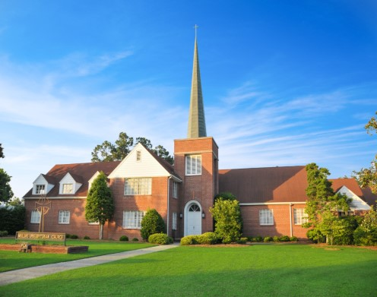

2022

“A YEAR TO RECONNECT”

